CHAPTER 1
INTRODUCTION
Project Context
Computers are being used in an increasingly wide variety of application areas, and their correct operation is often critical for business success and/or human safety. Developing or selecting high quality software products is therefore of prime importance. Comprehensive specification and evaluation of software product quality is a key factor in ensuring adequate quality. This can be achieved by defining appropriate quality characteristics, taking account of the purpose of usage of the software product. It is important that every relevant software product quality characteristic is specified and evaluated, whenever possible using validated or widely accepted metrics. Metrics is a standard of measurement by which efficiency, performance, progress, or quality of a plan, process, or product can be assessed.
Business registration and licensing is an important conduit to creating a thriving and robust business sector. It enables businesses, particularly small ones, to gain access to funding and to certain protections by the law. It also helps formalize the economy as registered businesses pay tax and deliver other important benefits to the economy, like job creation. The developers then thought of a special contribution to the economy with the aid of information technology with a clear sight of implementing a Business Permit and Licensing and Monitoring System for Municipality of Talisay.
The system will be a great convenience to its users. The process can run faster than the usual manual process which then entails people that need business permits as an easy way of getting it at a less time cost. The clients’ usual sort of problems concerning their business permits can be easily answered. The administrator can easily track down their record through the issued unique control number. The flow of getting a business permit will be highly secured and will not need much turnover process like in a usual manual process wherein, a big room with several tables and officers are flooded and very busy with their designated tasks in each of the step by step flow of manual business permit licensing. An easy and a fast process can get rid the possibility of getting the office crowded and make a lot of clients wait for a very long time. This can also boost up local economy and tourism in relation to the local entrepreneur’s business registers. Moreover, tracking automatically entrepreneurs’ business permits expiration ahead of time will be one of the sole preventive measure of the monitoring system. With these, the developers decided to have a Decision Support System (DSS) to help a Local Government Unit (LGU) that will aid entrepreneurs who wanted to register their businesses, renew current business licenses, and those who have expired business permits.
Purpose and Description
With the use of modern technology, releasing of business permit and license will be easier than usual. In connection to this, some machines that are highly operated by electricity/ battery that can link into a LAN based connection can access it easily and can transact to their offices and they easily record the information of the client and their business.
To the College of Engineering and Computer Science Department, the information and experiential knowledge gained trough this study can be utilized in discussion, advocacy and other related activities. It promotes the diverse application of information technology to LGUs, government, economy, entrepreneurs and their businesses.
To the Municipality of Talisay, this project set forth as a reference on the performance of the LGUs in the city. This can also aid the relationship of the clients and BPLO of the Municipality of Talisay in having an easy way transaction with office and faster way of processing business permit licensing and monitoring.
To the Future Developers, this may serve as an inspirational to conduct further studies that will explore a wider scope. Information presented in this study could serve as a baseline data and reference for future researches related to the project presented. Lastly, this will also serve as humble contribution to the enrichment of local literature on the matter.
Objectives of the Study
The general objective of the project is to develop a Business Permit and Licensing and Monitoring System for the Municipality of Talisay.
Specifically, it will aim to achieve the following:
- To develop a module where the users can process the following:
  - business permit for;
    - new registrees; and
    - renewees.
  - assessment of fees;
  - generation of reports; and
  - monitoring of business permits.
- To test and evaluate the proposed system if it conforms to the ISO 9126 software evaluation criteria such as:
  - functionality;
  - usability;
  - efficiency; and
  - maintainability.
- To develop an implementation for the proposed system.
Scope and Limitations
This system opt to provide a business permit and monitoring of different businesses in Talisay. This system will provide a relevant, effective, appropriate business permit. Moreover, this system will also provide convenient and efficient monitoring of expired and expiring permits. Also, the system can generate fees of the account for every business applicant but cannot accept payment transaction.
The project focuses on the objective of the project, which is to create a business licensing system and monitoring for the Municipality of Talisay. The scope and limitations is to revolved first on identifying profiles of the respondents. The study employed highly quantitative design which is solely based on a scientific positivist approach where hard data are construed to verify an existence.
The project methodology has limitations. Other areas important to business such as markets, computer shop and other business the quality of its infrastructure services (other than those related to trading across borders), the security of property from theft and looting, the transparency of government procurement. Because standard assumptions are used in the data collection, comparisons and benchmarks are valid across economies. The data not only highlight the extent of obstacles encountered by the new and renewal applicants; they also help identify the source of those obstacles. The project provides a description on the performance of the LGUs in the city. The processes and transactions of respondents in the local agencies in getting other requirements for business permits were also described in the study but were given minimal attention.
Definition of Terms
For more comprehensive understanding of the study, the following terms were defined conceptually and operationally.
Application. It is a software program that performs one of the major tasks for which a computer is used [1]. In this study it served as a computer program or piece of software designed to help the BPLO office in the municipality of Talisay to perform certain type of work regarding business permit licensing and monitoring process.
Business Permit and Licensing. A combination of hardware, software infrastructure and trained personnel organized to facilitate business permit licensing processes [2]. In this study, it is an electronic – based system served as a single point of processing business permit licensing.
Corporation. A corporation provides limited liability for the investors. As an exception, none of the shareholders in a corporation is obligated for the debts of the corporation; creditors can look only to the corporation's assets for payment. The corporation files its own tax return and pays taxes on its income. A corporation has some tax benefits such as deductible of health insurance premiums [3]. In this study, it pertains to a large business or organization located in the area of Talisay, Batangas that under the law has the rights and duties of an individual and follows a specific purpose. It consists of people who own an entity of getting business permit.
General Partnership. In a general partnership, each of the two or more partners will have unlimited liability for the debts of the business. The income and expense is reported on a separate return for tax purposes, but each partner then reports his or her pro-rate share of the profit or loss from the business as one line on his personal tax return [7]. In this study, it has a synonimous application wherein it refers to a partner whose liability for partnership debts and obligations is unlimited.
"S" Corporation. A corporation that has made an election to be an "S" Corporation for federal income tax purposes is treated as a partnership for tax purposes, although it is treated as a regular corporation for other purposes [8]. Operationally, it has the implication in the study.
Limited Partnership. With a limited partnership, each of the general partners has unlimited liability for the debts of the partnership, but the limited partner's exposure to the debts of the partnership is limited to the contribution each has made to the partnership. With certain minor exceptions, the reporting for tax purposes is the same as for a general partnership [9]. Operationally, it simply refers to a partnership of having one or more general partners and or more limited partners
Monitoring System. A combination of hardware, software infrastructure and trained personnel organized to facilitate the supervision and monitoring of the activities in progress to ensure the on – course and on – schedule in meeting the objectives and performance target [10]. In this study, it is an electronic – based system that will be utilized by the administrator to monitor the information and status of licensed businesses within the Municipality of Talisay.
Sole Proprietorship. A sole proprietorship is one person alone that have unlimited liability for all debts of the business, and the income or loss from the business will be reported on his or her personal income tax return along with all other income and expense he or she normally reports (although it will be on a separate schedule). Although proprietorship avoids the expense of forming a partnership or corporation, many start businesses this way because they are unfamiliar with the other forms of organizations [11]. In this study, it pertains to an individual who own and manage his or her own business located in the are of Talisay, Batangas.

CHAPTER 2
REVIEW OF RELATED SYSTEMS
This chapter presents the gathered related systems, data and information relevant to the development of Business Permit and Licensing and Monitoring System. These helped the developers provide the needed information for the enrichment and understanding of the proposed system at hand.
Technical Background
This section gives further explanation to the present development of Business Permit Licensing and Monitoring System for the Municipality of Talisay. It also covers discussion on the current technologies used in developing and implementing the proposed system. The developers gathered information from different books and references that are deemed significant for the development of the system.
Business permits and licensing involve complicated tax computations, manual, paper-based processes, and voluminous records. The development of Business Permit and Licensing and Monitoring System for the Municipality of Talisay will simplify business permits and licensing operations by automating the permit application process, assessment of taxes and fees, billing, payment, and liquidation of collections.
The development of Business Permit Licensing and Monitoring System for the Municipality of Talisay, Batangas will dramatically reduce transaction time, and practically eradicates underassessment or miscalculation of taxes and fees by keeping human discretion to a minimum. The system will also enable LGUs to monitor compliance of businesses with their tax obligations. The management and statistical reports generated by the proposed Business Permit and Licensing and Monitoring System for the Municipality of Talisay will allow LGUs to establish patterns of business tax compliance, and facilitate enforcement of focused collection strategies.
The proponents will use VB.Net 2010 because of its compatibility and appropriateness to the system. This language is also easy to explore because of its English like feature. It will provide the easiest, most productive language and tool for rapidly building windows. It will also support the creation of applications for wireless, Internet enabled hand-held devices.
The MySQL for database is the purpose of this system. The Vb.Net is design for the system and command by the code that is why MySQL and vb.net were connected because the vb.net will update the gathered data to MySQL database.
It’s the ability of the applications that use the databases that support the business that matters. For applications where the development process would benefit from an unlimited approach to licenses and multiple-platform environment support, MySQL would be a superb alternative.
MySQL is an open source software product, originally established independently but now owned by Oracle. It is a RDMS (Relational Database Management System) that uses its own “dialect” of SQL. MySQL can be used on multiple platforms and has the ability to use multiple storage engines for individual tables, wherein the user can choose the most effective one for a given table. MySQL can run in clusters for high availability. In terms of security, technologies are however EC2 compliant and have adequate security support for building applications at government level.
The software specification for the server of the system are Windows XP, Windows 7, 8, 10 and Windows Vista for the operating system specification; VB.NET 2010 for the programming language specification; and XAMPP for the database back - end. Windows 7 and Windows 10 are the operating systems used to create the project because these are considered as the most compatible among the other application used by the developers. Meanwhile, Windows XP, Windows 8 and Windows Vista were also tested to verify the flexibility of the developed system. Added to this requirement is the VB. NET 2010 which was used as the programming language. Lastly, XAMPP was used as the database back – end to surely meet the specification requirement for the system.
The system will also utilize certain hardware and tools together with its functions to meet the proper standard needed to the development of the system. Intel/AMD will be the minimum hardware specification required for the architecture equipment of the system. While for the processor speed, a 1.2 GHz and above is required for the system to function properly. Meanwhile, a RAM of 1500MB with a minimum of dual core for the CPU is needed. As for the hard drive, the system will require at least 2GB free space memory as the minimum requirement. However, there are no required specifications for the graphics card and webcam. Utmost, an optical mouse with touchpad is needed also as a hardware requirement in the system.
The architectural diagram of the proposed system was illustrated on figure. The Business Permit and Licensing System and Monitoring System can be used by the BPLO, Treasurer Office, Health Dept., and Fire Dept. The BPLO can manage and operate the system while the other office or department is connect through LAN connection to get the faster information of the client. The information can be held at the database of the system.
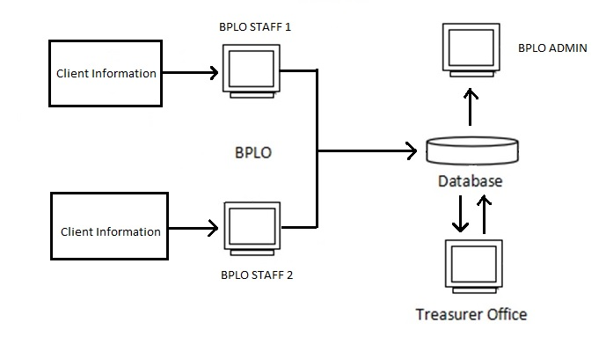
Figure 1. System’s Architectural Design
Related Systems
The following researches have been gathered to guide the proponents in developing the Computerized Business Permit and Licensing Offices.
In the study of Añes, et al., [9] Company’s accounting concepts and policies are in accordance with the existing accounting standards and properly directed by the management. With regards to the general accounting procedures, the results show that all business transactions are done accordingly. Business forms and financial reports are with agreement with the business transactions done. Financial reports and business forms are catered with the company’s requirements. Thus, encompassing good accounting practices is beneficial and is helpful in efficiently conducting the day to day operations of the company.
The difference between Highlighting the Operational Concerns and Accounting System of Selected Computer Rental Shops and the present system is, The Highlighting the Operational Concerns and Accounting System of Selected Computer Rental Shops discussed about the general accounting procedures to make it more efficient and easier of conducting the operations of the company, while the present system, that will provide an easy steps on how to get a Mayor's permit by complying all of the requirements as soon as possible.
The City Hall of Nairobi, Kenya Glt hinji which stated that plans are underway for traders within the City of Council of Nairobi (CCN) to apply and pay for a single business permit through an electronic system. City Council Chief Licensing officer John Gitau told financial journal the system would reduce long queries and that within a day or two applicants will be issued with trading licenses. It will be easier for our customers to pay through electronics systems such as in-banking and apply for the license electronically, Gitau said. The project is being undertaken through the CCN initiative of reforms in order to attract more investors. The new system is affected to be in place by June this year.
The difference between e-License for Single Business Permit and the present system is, e-License for Single Business Permit can issued trading license for a business within one day for two applicants while the present system, there will be an issuance of the Mayor’s Permit if the requirements are fully complied.
The study was developed for issuance of permit, provided a system that would improve storing of information and improve the government service and resolve all the difficulties in applying a business license. The researchers discussed the permits would be given by the licensing officer to reduce the traffic on other departments and also make the transaction faster and efficient. One of the similarities of the conducted study to this study was develop a system that will improve storing information and resolve all difficulties in applying a business license. On the other hand, this study was designed in visual basic 6.0 and Microsoft Access for its database.
There are lots of comparisons between the related system and the present system such as they can resolve all the difficulties in applying a business license to make the system more efficient and faster.
Steer, L. M.D. [10] they cited that this system discussed about all the computation of building permit fees. This system allows the user to compute for the net salary of a specific employee. It also consists of personnel and file management. It enables the user to manipulate data with specified limitations. This system is protected by a security password to avoid illegal access of unauthorized user. This study uses Microsoft Visual Fox Version 5.0 as the programming language the system used in this study is also the issuance of permit. The system both allows the user to compute all fees of an applicant. The difference between the two studies is the proposed system is used for the issuance of business permit while the said study is for the issuance of building permit.
The mentioned system has the same function like the proposed system. They were both permit issuance but the only difference of the Building Permit Issuance, Payroll and File Management System is they are discussing all of the computations of the building permit fees while the present system will issue a business permit as soon as the requirements are fully complied.
The study of Briones was designed to help the employees of NFA to learn their work using computerized receipts and reports. The proponents used networking in the system has many advantages like of sharing of peripheral devices, program and data better communication, security of information and access to database. In this project, the proponents linked Access 95 to Visual Basic 5 to create quicker retrieval of information form files and it saved time in data preparation. In doing this project the proponents learned how to design a system development in computerized form. This study is similar to the Computerized Business Licensing and Permit Office because employees worked using computerized receipt and reports. The proponents also used networking. The two studies were developed in computerized form. However, they differ because they create a different language and database.
There are difference between of these two systems. Because the Licensing, Marketing and Inventory Network System for National Food Authority is used to help employees to learn their works using computerized receipts and reports. While the present system is develop to help businessmen to make it easier when it comes of taking a Business permit or Mayor’s permit.
The local government of Puerto Princesa City, Palawan had a Business One Stop Shop (BOSS) Magdayao [11] activity for the renewal of business permits of the businesses around the city. The Business Permit and Licensing, Regulatory, Enforcement and Monitoring Unit (BPL-REM) headed by Thess Rodriguez, BPL-REM Head said that the process of renewal was fast but during the activity but there only had a problem with the 'queuing device' because of the frequent power outages.
The difference of Business One Stop Shop and the present system is, the Business One Stop Shop is an activity of renewal of business permit while the present system is to make the process of taking a business permit more efficient, easier and faster.
[12]As cited from Get your Business Permit in One Hour at Cabuyao’s One-Stop Shop published by Philippines-Canada Local Government Support Program, Cabuyao, Laguna is a rapidly urbanizing 1st class city of 106,000 people, with many investors and entrepreneurs attracted because of its proximity to Metro Manila. Cabuyao has thus seen the rapid influx of businesses, and consequently, the resulting flood in applications for business permits and licenses. Initially ill-equipped to deal with the sudden rise in such transactions, processing business permits became a headache for the municipal government and business people alike. Then the LGU came up with the idea for a One-Stop-Shop for business permits processing.
Chapter 3
DESIGN AND METHODOLOGY
In this chapter, the developers provided the methodology and concepts used to develop the system. Designs and screenshots are also displayed and detailed the discussion on how it works in this part. The process used by the developers is logically presented using figures.
Project Concept
The developers conducted the project system by means of data gathering and understanding the situation that could help the Municipality of Talisay. The client record of a business permit have to input in Microsoft Office and take record and monitor every client that need to renew their permit and be recorded.
The developers also encountered concerns about how the record be input and keep all the data about the permit of their business. Apparently, they get the report through typing down there data and print out and writing in a manual book or sheet that may only cause manual error on both part of the client if any data seemed inappropriate or incomplete.
The project is develop using RAD Method as shown in Figure 2. [14] Martin, James (1991). Rapid Application Development. Macmillan. ISBN 0-02-376775-8. Rapid application development (RAD) is both a general term used to refer to alternatives to the conventional waterfall model of software development as well as the name for James Martin's approach to rapid development. In general, RAD approaches to software development put less emphasis on planning and more emphasis on process. In contrast to the waterfall model, which calls for rigorously defined specification to be established prior to entering the development phase, RAD approaches emphasize adaptability and the necessity of adjusting requirements in response to knowledge gained as the project progresses. Prototypes are often used in addition to or sometimes even in place of design specifications.
Figure 2 shows the requirements planning diagram which combines elements of the system planning and systems analysis phases of the Rapid Application Development (RAD) method used by the developers. This figure represented the phases encountered throughout the development of the system.
Planning is the first phase which discussed the whole analysis and the requirements needed for the system. In this phase, the developers analysed critically the problems that were encountered by BPLO and carefully decided on the system that can help the present operation.
The second phase is the System Design. This phase discussed the specifications that covered the requirements needed to produce the general aspect of the developed system.
The third phase is the Development which involved the layout interface as the prototype. In this case, the activities of the project are needed to be shown. The developers also analysed the interface and content that can be displayed in the system.
The next phase is the Testing. Different testing methods were applied in this phase to test the functionality of the system. Through this phase, the developers detected software failures and discovered some defects but also corrected immediately.
Output/Deployment was the last phase. Wherein the client started to use the system. The client and the developers had an agreement in the very first beginning that when the system is done, the developers will donate the said system in the client.
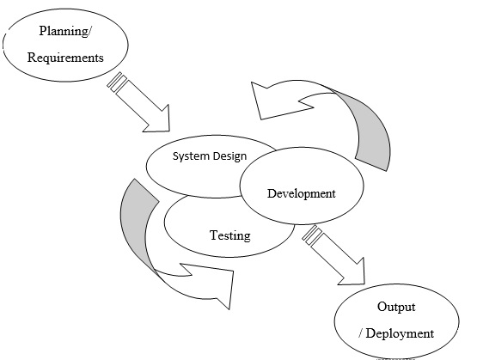
Development Method

Figure 2. Rapid Application Development Diagrams
Developmental Approach
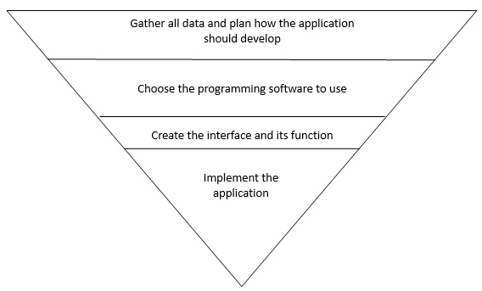
Figure 3 explain the Top-Down Approach used by the developers. It refers to the breaking down of a system to gain insight about the compositional subsystem. Using this development approach, the developers started with the planning of the project requirements. When this was planed the developers put together their ideas to come up with a unique plan that would cater to the demands of the municipality. Next was the analysis of the project to validate the plan and ensure that it is applicable to the needs the environment .The developers also implemented the system to tests its individual features and sub-units. Through software testing, the developers were able to get feedbacks for the improvement of the project system. Moreover, it enabled the developers to check and fix bugs and errors. As the target user approved the system, the developers then started to design the system. In this stage, the developers used software specification to create a good system. After the overall design and code of the system were finished, the developers began to test the proposed system then implement it to the Municipality of Talisay. The municipality continued to participate and suggested changes and improvement as actual screen or reports were developed. As a result, a new system was built, delivered, and immediately place in operation.

Figure 3.Top-Down approach
Figure 4 shows the current system of the BPLO. The admin/staff will input their username and password to login in the system, while the treasurer will input their username and password to access the treasurer transaction system. The system will display the information of the business of the client. Then, the admin can update the some information in the system, the admin can monitor all the data and update their information, while the staff can transact and monitor only and the treasurer can transact the payment of the client and release their certificate and receipt.
The BPLO user can also see the records of the business, and search the client. The staff records the information of the client as well as the client business information in the database 1 or the record information database.
0
Business Permit and Licensing and Monitoring System
BPLO Users (Admin/Staff)
Treasurer

Input the data information of the client
Display Information
Send an information in the treasurer office
Update and release the permit, receipt and plate
Figure 4. Context Flow Diagram of the Proposed System
Figure 5 shows the Data Flow Diagram of the existing system. In using this system the staff will input the information for new business permit. The client must present the requirements for the business permit, at the staff or admin will record the information about the business and the client information and send to the treasurer for the billing and releasing the permit and plate.
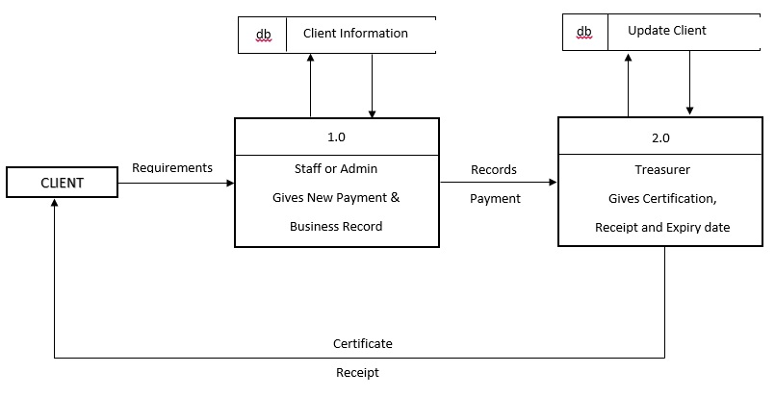

Figure 5. DFD for the New Business Permit Licensing Process
Figure 6 Update the business and if the client is for renewal the staff search the name of the client and must present the requirements for the renewal business permit, and send it to the treasurer, and the treasurer compute the billing for the renewal of the business, and the treasurer will release the business permit and plate.

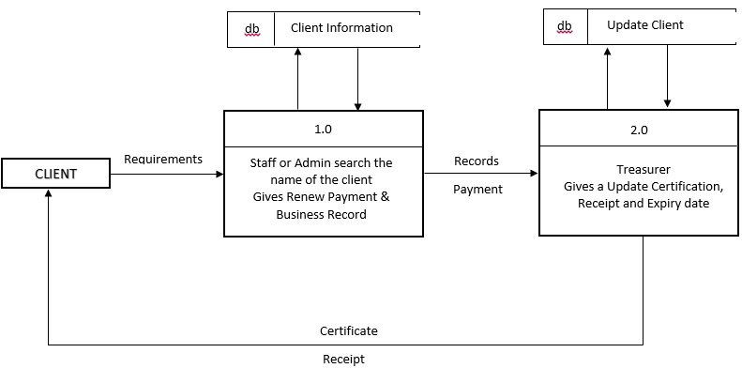

Figure 6. DFD for the Renewal Business Permit Licensing Process
Figure 7 the system also handles a module for client’s payments. Show the process for renewal, the treasure will update the record of the client and transact the payment of the business and give the certificate of the business and their receipt and the plate number.
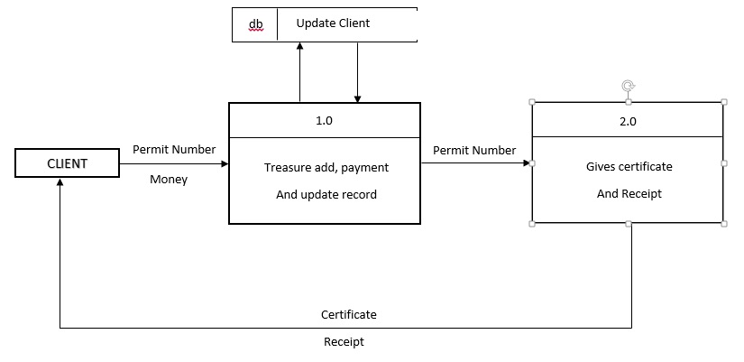

Figure 7. DFD for the Treasurer Payment Process
User Design
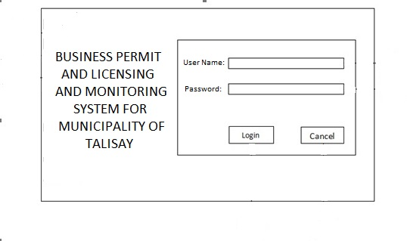
Figure 8 shows the Log in form of the system. This form is used to enter the system using the user account. Username and Password is required to be filled up before clicking the Log in button and if it is correct the system will redirect the user to the Home form of the system. The user will have restrictions depends on the user accounts they used, There are three types of roles the users can choose, Administrator, BPLO staff and Treasurer staff. Administrator can add user accounts and can view and manage the transaction business forms but in treasurer form, admin and BPLO staff cannot transact in the treasurer payment form.

Figure 8. Log In Form
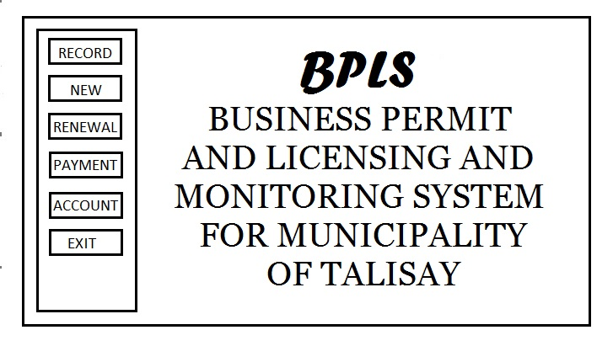
Figure 9 shows the home form of the system. Both the administrator and BPLO staff can view this form after login. In this form the user can choose which module he will view. Business Record to gather all the information of the client if it is a new apply for the business permit or for renewal purposes. And the New Business permit to create a new record of business permit for new applicant. And then Renewal Business Permit for updating purposes. Treasurer Button to see the billing and final 1 output or final permit. Account button to see all the information and accounts of all staff and only the admin can access the account in the system. Exit button to close the system and all the transaction will be invalidate and will return in the Log in form.

Figure 9. Main Form
Figure 10 Record Form since the client record are listed in the table, the figure 9 is used to edit the information of the client, and in figure 10 is used to renew the business of the client who has expired. And search the client in the search textbox. The Home button is used to close and back to the Main form.
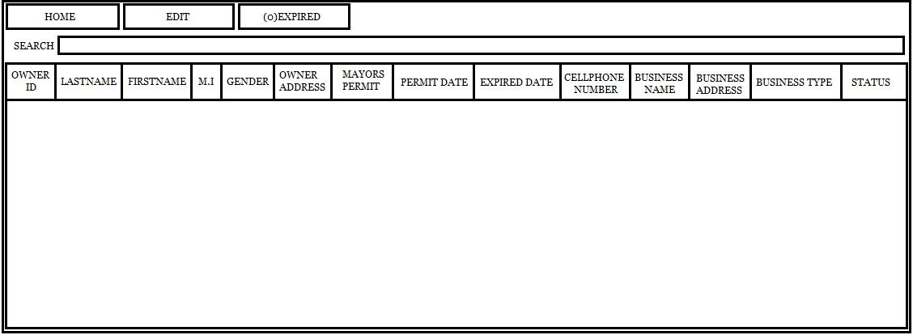

Figure 10. Record Form
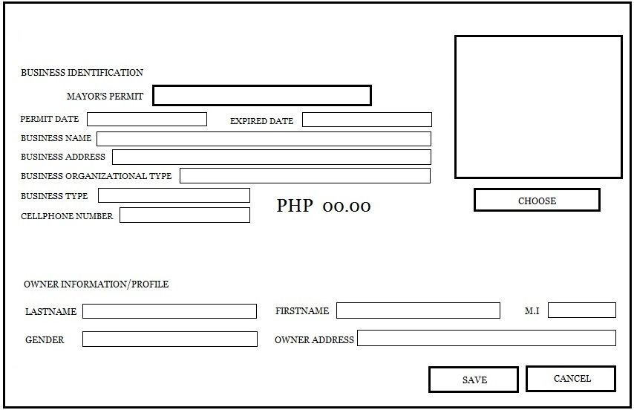
Figure 11 Edit information, need to select first the desired client and click it in the table then edit the information you want to edit and save, the information is automatic appear in the information details.

Figure 11. Edit Information Form
Figure 12 Home button will back in the Record Form, and click first the desired client and click it in the table, or search the client, then click the renew button, and in the Figure 12 in renew business form you need to complete he requirements and click the button show to change the year, and then click save.
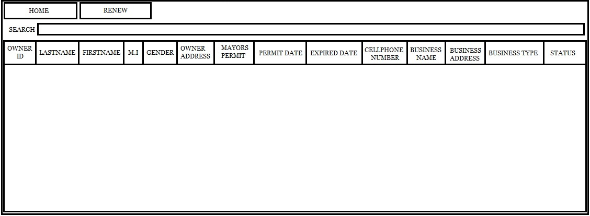

Figure 12. Expired Date Record Form
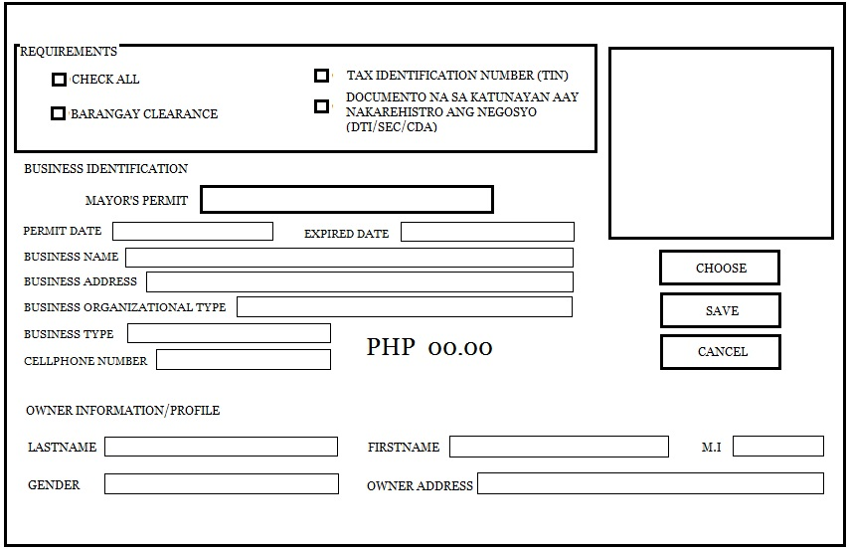
Figure 13 First you need to complete the requirements to enable the information, if you complete the requirements it will automatic compute the expired date of your business, and automatic appear the mayor permit number, and you need to complete the information and choose what business type and it will show the prize of your business you applied, then choose a picture then click the save button to save your business application. And Cancel button will disregard this information and will back in the main form.

Figure 13. New Applied Business Form
Figure 14 This is like the same as new business, but in this form, there have a search, just search the name or other information of the client, and automatic appear the information of the client, then you need to complete to continue the transaction process, and click the show button to update the year of your expired date, then save button, if all data are complete and the Cancel button if you want to cancel the transaction process.
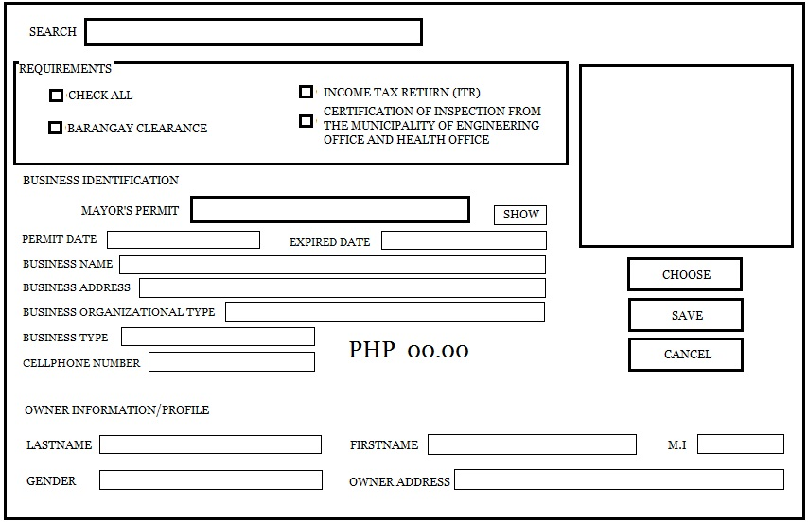

Figure 14. Renewal Form
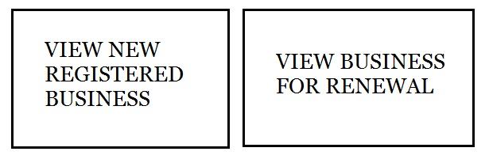
Figure 15 In this form you need to choose what transaction, if you click the view new registered business, it will show all of the new client in the table, the if you choose the view business for renewal, if the business is expired you will see in the table all of the expired business.

Figure 15. Treasurer
Figure 16 in this form you will see all the new business in the table. The Home button this function will go back in the main form, then the Transact button, you need to select first the desired client and click it in the table then click the button transact then Figure 15 will show the payment form. The search button, if you want to search the name of the client.
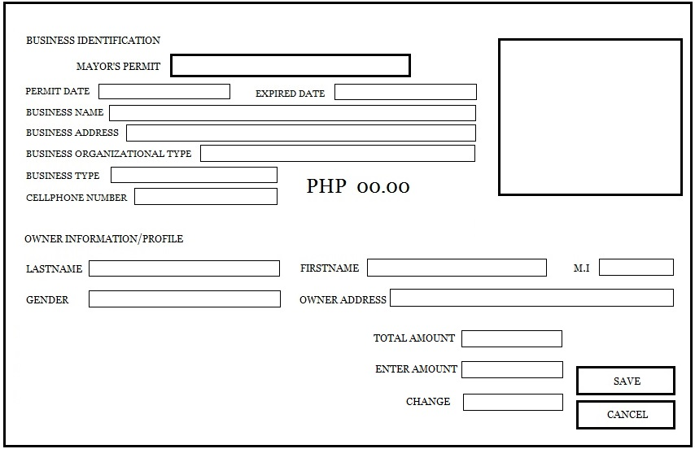

Figure 16. List of New Registered Business
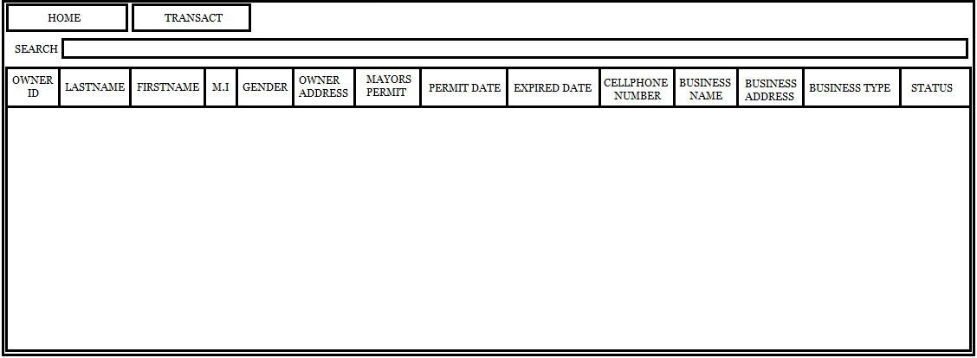
Figure 17 this is the payment transaction, if you select the desired client will appear all of the data, then you need to type the amount, then automatic appear the change of the client, then Save button, to save the transaction and update the record, and the Cancel button to cancel the transaction. And the treasurer staff will release your receipt and certificate of your business and you plate number.

Figure 17. Payment Form
Figure 18 Add/Edit User, Client Record, and Add/Edit Client Information, Transaction Record form all of this can be viewed and managed by the administrator. While the BPLO Staff can view the Client Record, and can edit the information of the client and can view the Transaction Record, Then the Treasurer Staff can only access the Transaction Payment and Transaction Record.
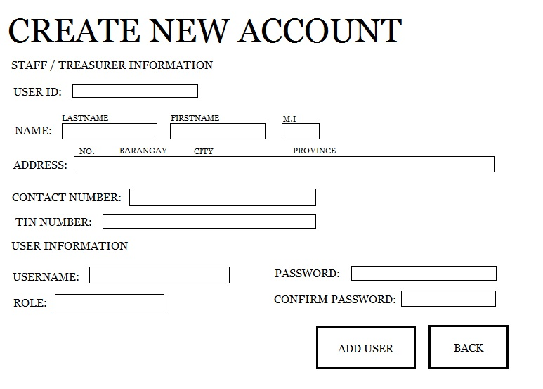

Figure 18. Create Account Form
Functional Requirements
In order to develop a successful system, the developers had to meet requirements specification needed. The requirements specification is very essential during the developmental process in order for the developers to get a clear cut idea on how to develop the proposed system.
The system also provides a simple graphical user interface which make it easier for the users to manipulate the system like adding a record for applying business permit and updating the renewal of the client and monitoring system in providing a more reliable service to the client of Municipality of Talisay where they can avail their business permit as easily transact.
Table 1
Functional Requirements
Characteristic/Attribute | Description
Login/Logout | The proposed system must ask the user for identification.
Create New Business Permit | The proposed system will allow the staff to create new permit (for the client).
Update Renewal Business Permit | The proposed system will allow the staff to renew their business to update their permit.
Monitoring Record | The proposed system will allow the staff and admin to view the record for business permit.
Billing Permit | The proposed system will allow the treasurer will compute and release the permit and plate.

Non – Functional Requirements
Non- Functional requirements detail constraints targets and project constraints in implementation on the organizations hardware/software platform, Non-functional requirements may cover the system as a whole or relate scope, functional requirements.
Table 2
Non – Functional Requirements
Attributes/Property | Measures
Speed | Processed transaction/Second User
Size | K bytes  Number of RAM chips
Ease of Use | Training Time  User-Friendliness
Reliability | Mean time to failure  Probability of unavailability  Rate of failure occurrence  Availability
Strength | Time to restart after failure  Probability of data computation or failures

Hardware Requirements
For the hardware requirements, personal computers. The hardware requirements mentioned are needed for a better approach with the system. These can also help the user to operate the develop system properly and accurately.
Table 3 shows the hardware specifications needed and the tools together with its functions to meet the proper standard needed by the develop system. For the architecture equipment, the minimum hardware specifications required is any version of Intel/AMD. While for the processor speed, a 1.2 GHz and above is required for the system to function properly. Meanwhile, a minimum dual core is needed for the CPU together with the RAM of 1500MB.
On the other hand, the minimum hardware requirement for the hard drive is at least 2GB free space memory. There are no required specifications for the graphics card. And lastly, an optical mouse with touchpad is needed in the system.

Table 3
Minimum Hardware Specification for Server
EQUIPMENTS | SPECIFICATIONS
Architecture | Intel/AMD any version of processor
Processor Speed | 1.2 GHz and above
CPU | Minimum of dual core
RAM | 1500 MB
Hard Drive | At least 2 GB free space
Graphics Card | Any
Webcam | Any

Software Requirements
Table 4 illustrates the software specification for the server of the developed system. These are the requirements for the users so that the website can run in properly. The developers used these requirements for the users benefit. Windows 7 and Windows 10 are the operating systems used to create the project because these are considered as the most compatible among the other application used by the developers. Meanwhile, Windows XP, Windows 8 and Windows Vista were also tested to verify the flexibility of the developed system. Added to this requirement is the VB. NET 2010 which was used as the programming language. Lastly, XAMPP was used as the database back – end to surely meet the specification requirement for the system.
Table 4
Minimum Software Specification
Software | Types/Specification
Operating System | Windows XP, Windows 7, 8, 10 and Windows Vista
Programming Language | Vb.net 2010
Database Back – end | XAMPP

Methods of Testing and Evaluation
To deliver a higher quality of system software that will satisfy the users, an effective software testing is a must. The proponents used the User acceptance testing. Each team members should conduct the said testing method, all the functionalities of the developed system. The developers will do several testing of possible inputs and outputs to ensure that the system that will be deployed is at its highest quality.
System Evaluation
Associated with the above testing methods was the use of survey questionnaires to evaluate the system. The developers used International Standard Organization (ISO) 9126 Software Evaluation Criteria as a reference in making questions included in the survey questionnaire. Certain criteria like the functionality, reliability and efficiency was considered in the system evaluation.
Functionality refers to the specified properties or attributes of the system. It determines whether the system satisfies the needs of the user, and if all the functions provide the desired output of the user. Reliability refers to the ease of which the system functions can be easily learned and understood. Lastly, in the efficiency category the time and resource behavior of the system is being monitored. In this, response time to a given throughput is important and being observed. Table 3 below indicates the scale of rating and the verbal interpretation of each assessment.

CHAPTER 4
RESULTS AND DISCUSSION
This chapter presents the result and discussion on how the system has been developed as well as the screenshots, evaluation results and observation about the developed software. It contains the actual observations of the developers and the users regarding the functions of the software.

Business Permit and Licensing and Monitoring System
Figure 19 New Applied Business, before you go in BPLO there have a requirements you need to complete before you go to BPLO. (1) Need to Complete the Requirements to enable the next process to fill up the information of the client, and if the requirements is incomplete the transaction will not proceed in the next step. (2) Need to fill up all the Business Identification of the client, and automatic show the payment of the business. (3) Owner Profile, need to fill up the information to enable the choose button (4) Choose Button, this function will choose the picture in the computer. (5) Save button, this function will save the business and record the business in the database. (6) Close button, this function close the form and will back in the main form.

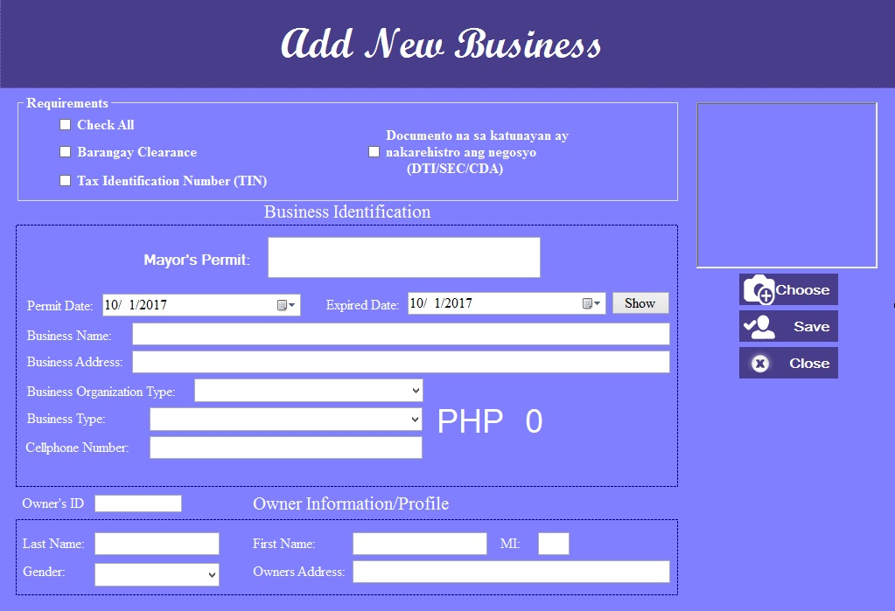

1

4
2
5
6

3

1
3
5
6
Requirements checkbox
Owner/Profile
Save Button
2
4
Business Identification
Choose button
Close Button

Figure 19. New Applied Business
Figure 20 Renewed Business (1) Search, you can search the client and automatic show the information of the client. (2) Need to Complete the Requirements to enable the next process to fill up the information of the client, and if the requirements is incomplete the transaction will not proceed in the next step. (3) Information of the client will show automatic if you search the name of the client. (4) Need to fill the Profile. (5) Show button, this function will change the year of the expired date, if client are updated in renewal select the button show to change the year. (6) Choose button, this function will choose of your picture, but there’s a recent picture. (7) Save button, this function will save the business and record the business in the database. (8) Close button, this function close the form and will back in the main form.
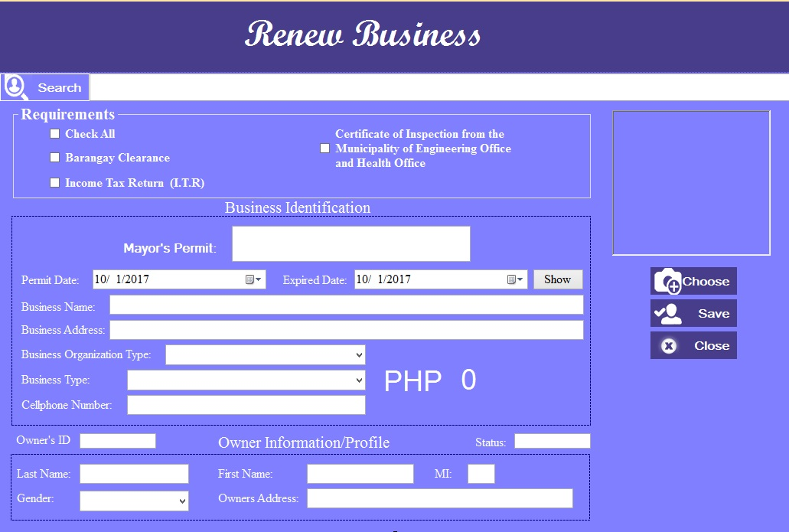
1

2

6
7
8
3

4
5

1
2
4
5
7
8
Search
Requirements Checkbox
Owner Profile
Show Button
Save Button
3
6
Business Identification
Choose Button
Close Button

Figure 20. Renewed Business Form
Figure 21 Payment Form (1) Enter Amount, you need to type the amount given by the client and automatic compute the change. (2) Save Button, this function will save your payment base on the amount of the business applied and save to the record. (3) Close Button this function close the transaction.
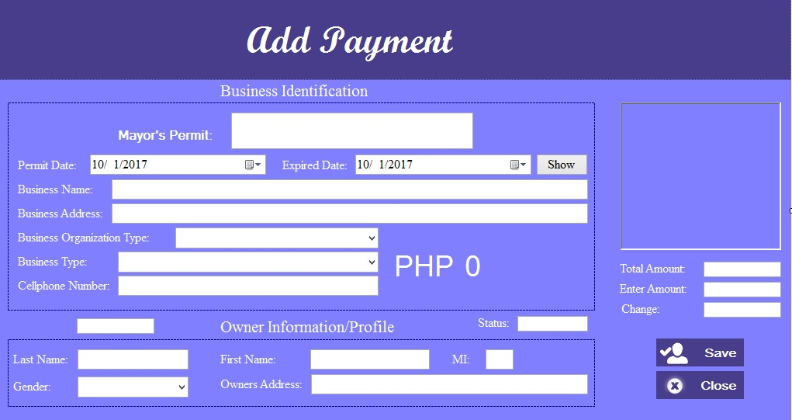

1

2
3

1
3
Enter Amount
Close Button
2
Save Button

Figure 21. Payment Form
Figure 22 Payment View (1) Home Button, this function will back in the treasurer form. (2) View Button, this function will view the transaction. (3) Search the client business. (4) List of Payment, view the transaction payment.

1
2



3

4

1
3
Home Button
Search
2
4
View Button
List of Payment

Figure 22. Payment View
Figure 23 Record and Monitoring (1) Home Button, this function will back in the main form of the BPLO. (2) View Record Button, this function will view the information of the client. (3) Add Records, this function will add a new business. (4) Edit Record Button, this function can edit the information of the client. (5) Need Renewal Button, this function will see the expired business of the client. (6) Back Button, this function will back in the treasurer form. (7) Search Button, this function can search the client name. (8) List of the New Business and Renewed Business.
1
2
3
4
5
6

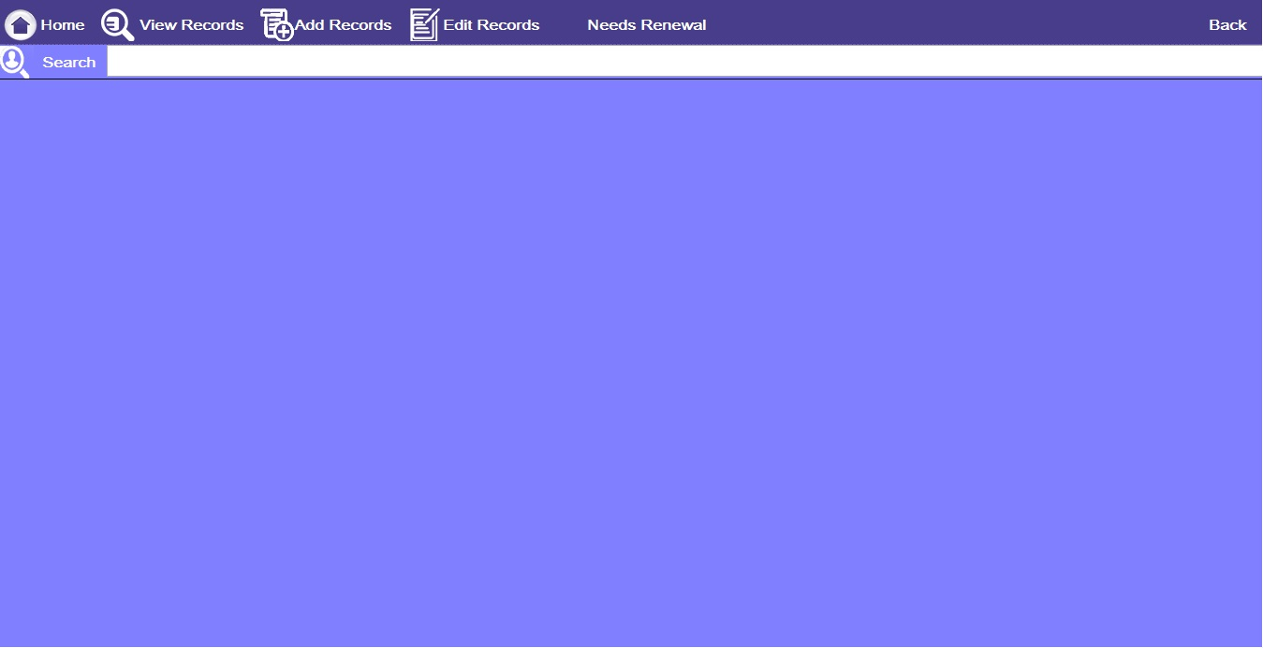
7

8

1
4
7
Home Button
Edit Records Button
Search
2
5
8
View Record Button
Needs Renewal Button
List of Record
3
6
Add Records Button
Back Button

Figure 23. Record and Monitoring Form
Figure 24 Login (1) Username textbox you need to input your username, there have an account of the admin, staff and treasurer. (2) Password textbox you need to input password. (3) Log in button is you input your username and password the system will appear in the main form and (4) Cancel button this button will close the login form.

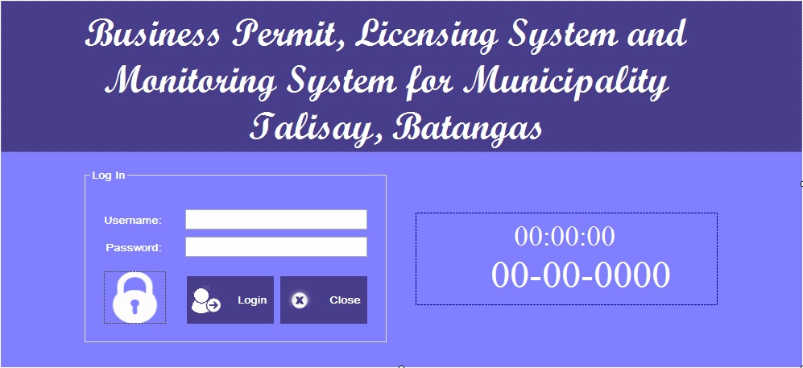

1
2

3
4

1
3
UserName TextBox
Log In Button
2
4
Password Textbox
Close Button

Figure 24. Login Form
Figure 25 Main Form (1) Business Record to gather all the information of the client if it is a new apply for the business permit or for renewal purposes, and monitor the expired business. (2) New Business to create a new record of business permit for new applicant and save the info of the client. (3) Renewal Business for updating purposes. (4) Treasurer Button to monitor the billing and output and the payment transaction but only the treasurer account can access the payment. (5) Account button to see all the information of the staff and accounts of all staff, only admin can access the account for updating the info. (6) Log out button to close the existing account.

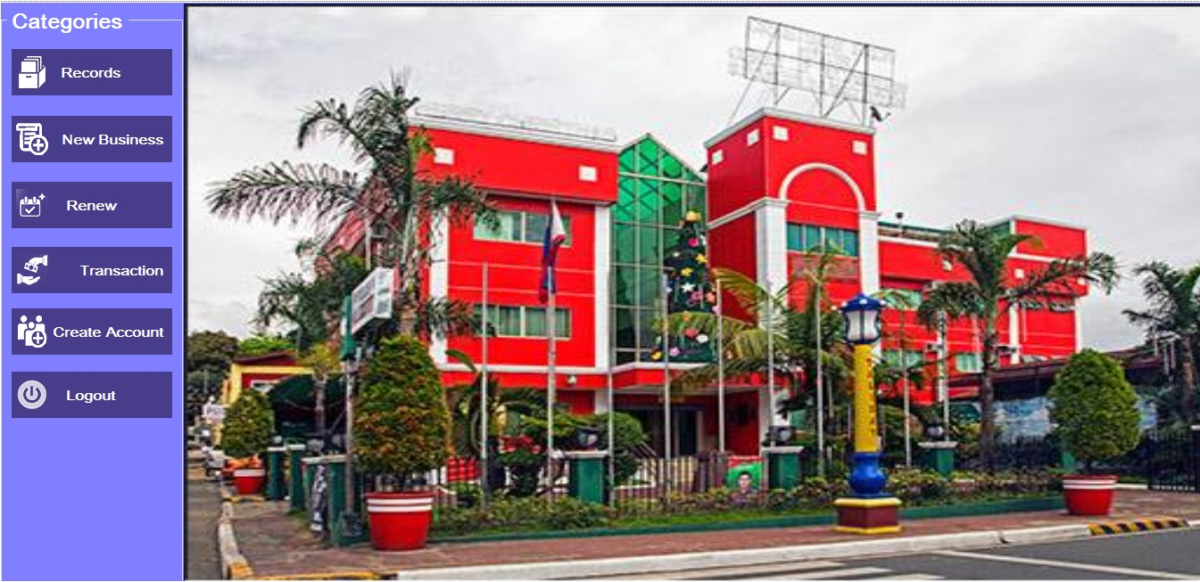
1

2
3
4
5

6

1
4
Record Button
Transaction
2
5
Create Account
New Business Button
3
6
Renew Button
Logout

Figure 25. Main Form
Figure 26 Update Client Information, this is edit information and update in the record. (1) Choose Button, this function will choose the picture in the computer. (2) Edit Button, this function will enable the client information and edit the information of the client. (3) Cancel Button, this function will cancel the update form.

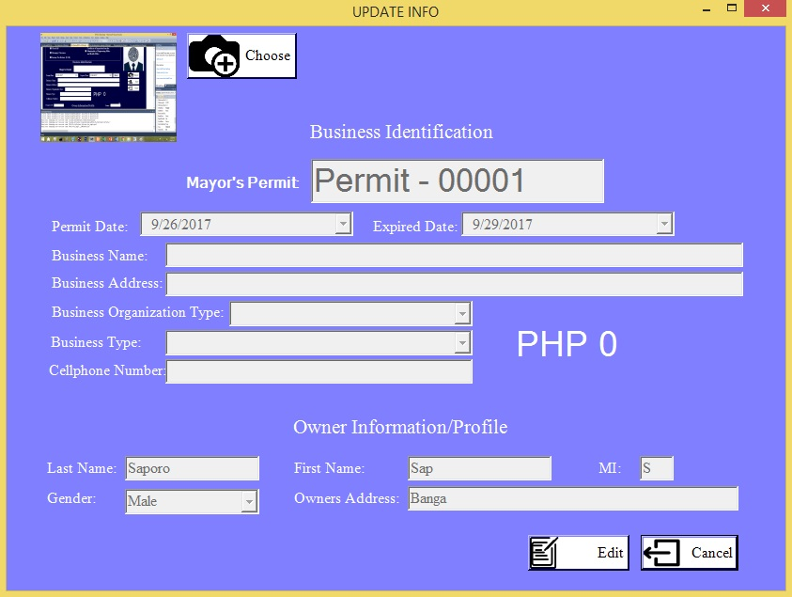
1

3
2
1
2
3
Choose Button
Cancel Button
Edit Button
Figure 26. Update Client Information

Figure 27 List of New Business Form (1) Home button, this function will go back in the main form. (2) Transact Button, this function will transact a new business. (3) Search to a client. (4) List of New Business.
1
2

3

4
1
Home Button
2
3
4
Transact
Search
List of New Business
Figure 27. List of New Business
Figure 28 List of Renew Business Form (1) Home button, this function will go back in the main form. (2) Transact Button, this function will transact a business need to renew. (3) Search to a client. (4) List of Need to Renew Business
1
2

3

4

1
3
Home Button
Search
2
4
Transact
List of Need Renew Business

Figure 28. List of Renewal Business
. Figure 29 Update Renew (1) Show Button this function will update the year of expired date. (2) Choose button will choose a picture in the computer. (3) Save Button will save the update information business. (4) Close Button this function, will cancel the update transaction.
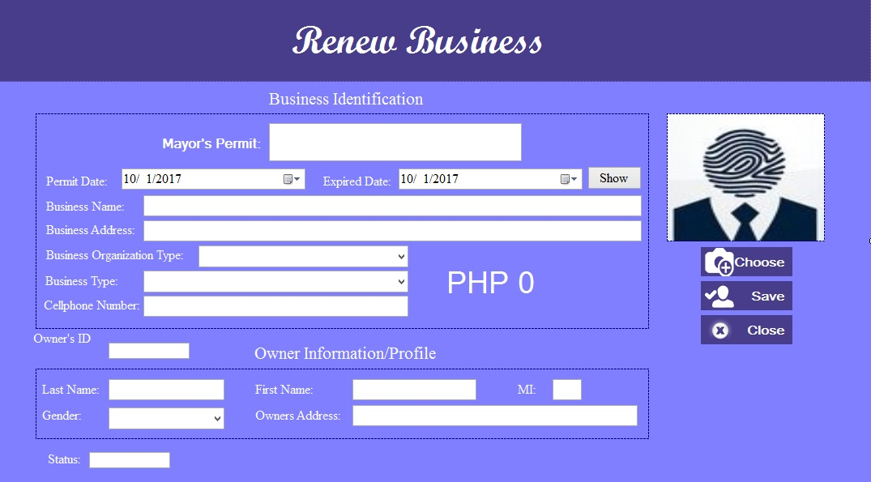

2
3
4

1
3
4
Show Button
1
Choose Button
Save Button
2
Close Button

Figure 29. Update Renew Business Form
Figure 30 Treasurer Form (1) Home Button this function will return in the Main Form. (2) View All Business this function will view all of the business in the database. (3) View New Business Records this function show all the new applied business. (4) View Record need to Renew will view all the expired business. (5) List of View Business.

1
2
3
4

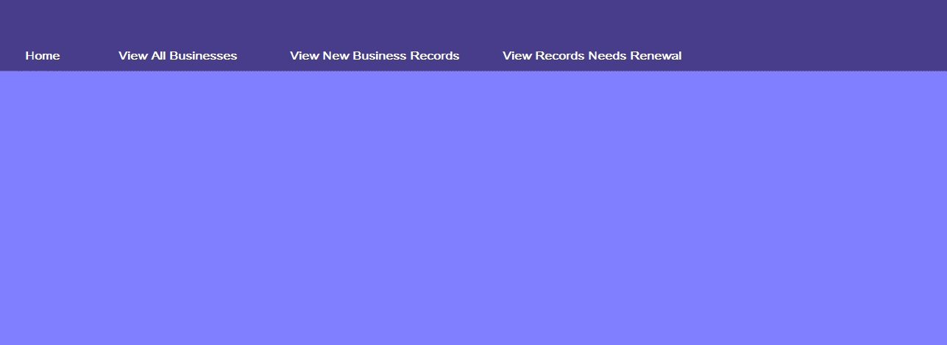

5

1
4
Home Button
View Records for Renewal
2
5
View All Business
List of View Business

3
View New Business Record

Figure 30. Treasurer Form
Figure 31 Create Account of the treasurer and the Staff of the BPLO. (1) User Information need to fill up the information to record the user in the database. (2) Profile Information need to fill up the information and choose the role of the user. (3) Save button this function will save the account and record in the database. (4) Back button this function will cancel the creating account and back to the list of account.

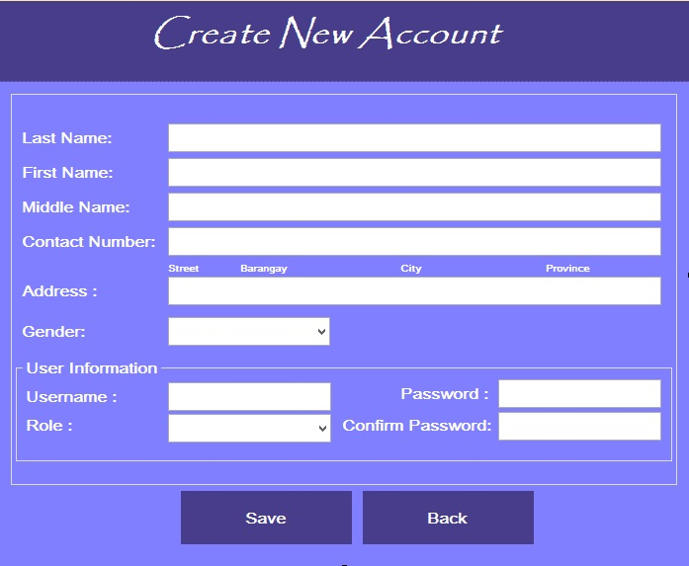

1

2

3
4

1
3
User Information
Save Button
2
4
Profile Information
Back Button

Figure 31. Create Account
Figure 32 User Record Form (1) Home Button, this function will return in the main form. (2) View Records, this function will view the information of the user account of officer and treasurer. (3) Add Records, this function can add a user of the officer and treasurer account. (4) Edit Records, this function can edit an information of the user. (5) Delete Record, this function will delete an account you selected.
1
2
3
4
5

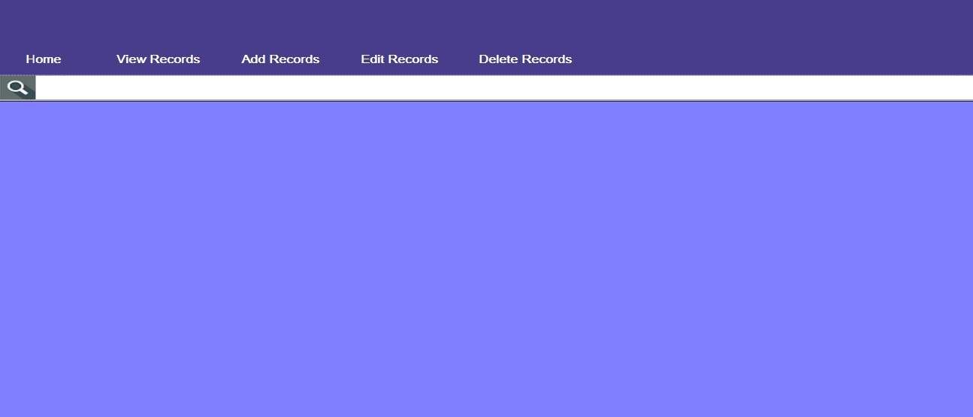

1
4
Home Button
Edit Records
2
5
View Records
Delete Records
3
Add Records

Figure 32. User Record Form

Evaluation Tool
The developers conducted a survey consisted of four categories. Each category has a corresponding question. This survey was made to find out the usability, functionality, efficiency and maintainability of the system created by the developers. It was participated by the management of the system to assess their responses.
The evaluation result focuses on the responses about the developed system. The evaluation focused on the usability, functionality, efficiency and maintainability of the system.
Table 5 presents the result of system evaluation of the administrator. The system is evaluated based on four chosen criteria as referenced from ISO 9126: usability, functionality, efficiency and maintainability. The respondents strongly agree that the system is easily to understand and to use with the weighted mean of 4.05. The respondents either agree or disagree to the design of the system is simple but effective with the weighted mean of 3.28. The respondents either agree or disagree that the application uses the most graphic size with the weighted mean of 3.54. The respondents agree that the screen is accessible via buttons with weighted mean of 4.09.
Table 5
Summary of the Result of Evaluation in Terms of Usability

Criteria | WM | Verbal Interpretation
1. Usability
1.1 The system is easy to understand and to use. | 4.05 | Strongly Agree
1.2 The design of the system is simple but effective. | 3.28 | Neither Agree or  Disagree
1.3 The application uses the most efficient graphic size. | 3.54 | Neither Agree or Disagree
1.4 The screen is accessible via buttons. | 4.09 | Agree

Table 6 shows the results of evaluation in terms of functionality of the system. The respondents agreed to the ability of the system to accomplish task on the first attempt of the user with the weighted mean of 4.2, the ability of the system to be easily understand by the users with weighted mean of 4.7. They strongly agree to the ability to provide reliable information with the weighted mean of 3.96. They agreed to the capability of the system to respond on time with the weighted mean of 4.1.
Table 6
Summary of the Results of Evaluation in Terms of Functionality
2. Functionality | Weighted Mean | Verbal Interpretation
2.1The ability of the system to accomplish task on the first attempt of user. | 4.2 | Agree
2.2 The ability of the system to be easily  Understand by users. | 4.7 | Agree
2.3 The ability of providing reliable information. | 3.96 | Strongly Agree
2.4 The capability of the system to respond on time. | 4.1 | Agree

Table 7 shows the result of evaluation in terms of system's efficiency. The respondents agree that the system responses on time with the weighted mean of 4.0. They also agree that the system provides reliable information with the weighted mean of 3.92
Table 7
Summary of the Results of Evaluation in Terms of Efficiency
3. Efficiency | Weighted Mean | Verbal Interpretation
3.1 The system responses on time. | 4.0 | Agree
3.2 The system provides reliable information. | 3.92 | Agree

Table 8 shows the result of evaluation in terms of system's maintainability. The respondents agreed that the system's buttons are all working based on the specified task with the weighted mean of 4.1. They also agree that the system's overall design is sustainable for the user to use with the weighted mean of 3.98.

Table 8
Summary of the Results of Evaluation in Terms of Maintainability

3. Maintainability | Weighted Mean | Verbal Interpretation
3.1 System’s buttons are all working based on its specified task. | 4.1 | Agree
3.2 The system maintained the records that undergo in the database. | 3.98 | Agree

The total amount of the four criteria is 3.99. The system is passed as the software of a good quality and functional system therefore it is easily to use effectively and reliable.
Through the use of the evaluation the satisfactory results from the survey so that the developers decided to continue improved the system work and dedication to be more efficient and fast processing of the system, they also keep on improving the system’s interface for the easiest use and function of the system.

CHAPTER 5
SUMMARY OF FINDINGS, CONCLUSION AND RECOMMENDATIONS
This is the last chapter of the study where the developers presented the findings of the whole project, the conclusions formed and the recommendation for the future developers as they come up with the developed system.
Summary of Findings
The project is conducted to have Business Permit and Licensing and Monitoring System for Municipality of Talisay.
The main purpose of this is they have manual process therefore we innovate the automated system to help the administrator and staff. This findings of the study are in the following:
1.1 Since the management used the manual process to get the business permit the developers added some of features to the Business Permit and Licensing and Monitoring System. The developers aims to have the fast and better way to have a Business Permit and Licensing and Monitoring System. This is the easy way not just for the administrator and staff but also to the community members.
1.1.1 The clients will take the fastest way of business permit through recording of BpLo of their information. The BpLo and Treasurer’s Office have two-way process of business permit, then the client turn to the treasurer’s office to pay and wait for the releasing of certificate, receipt and plate number.
1.1.2 For the renewees they will know the steps in getting their certificate, receipt and plate but it differs to the new clients because they need to give some requirements for their renewal of papers. The renewees tend to renew and give their requirements at the month of January.
1.2 The manual operation of processing payment for the business permit can be modified into an automated process for the administrator and client in order to process the payment quickly. The treasurer’s office gave the receipt of payment and they will give the plate number and permit.
1.3 The developers also developed a basis of data by generating reports.
1.4 The developer have two-ways process of business permit they are the BpLo and the treasurer’s office to monitor the information of the client.
2. The developers have an ISO 9126 software evaluation criteria by means of functionality, usability, efficiency and maintainability. To enhance the new process of Business Permit and Licensing, Monitoring System.
3. The developers develop an implementation plan for the developed system.
Conclusions
The developers provides a system that would help not only the employees/personnel’s but also the users by using the developed system. Based on the findings, the following conclusions where started.
1.1 The developed Business Permit and Licensing and Monitoring System for Municipality of Talisay can replace the manual process of business permit for the client.
1.1.1 The developed provides a two-way process of business permit so that can check the client’s previous records and transaction. With this feature, the two-way of process business permit can save a lot of effort in searching the client's history of business.
1.1.1 The developed system, it provides the BPLO staff to search the information of the client and check the all requirements then save as a renew.
1.2 There was an easy way for the payment, and is it an automatic computation to the system. So that the treasurer's office will give the business permit, payment receipt, and the plate number.
1.3 The Business Permit and Licensing and Monitoring System allows the Bplo and Treasurer's Office about the status of the clients. It has a lot of features that can generate the records about the profit and liabilities of the company and also reports for daily, weekly and yearly.
1.4 The developed system, provides the two-ways of process of business permit to ensure that the records of the system is monitoring to both offices in the database.
2. The developed system, have a ISO 9126 software to evaluation criteria by means usability, functionality, efficiency and maintainability to used in the function of the system and to help the conducted result we know the responsibilities of each.
3. With the use of the newly developed system, it can generate the reports which can be easily monitored by the treasurer of each barangay will ease the problem of giving the business permit, plate number and receipt manually.
Recommendations
Based on the findings and conclusions, the following recommendations are suggested. The recommendations are offered for future enhancements and improvements.
  - Providing SMS notifications could also be a good reminder to the clients to let them be reminded about the deadline of the expiration date of renew.
  - Adding online renewees and payment services for clients could also be useful for those clients that are busy and having less time to go and pay to the municipality.
  - The developed system is also recommended to the BpLo and treasurer's office, to use for fast and reliable way of acquiring clients's permit.

